Computer Language Coding Concepts

Pointer to Pointer in a Diagram
The concept of pointer to pointer is explained in the article Pointer to Pointer. The current article demonstrates it in a diagram.

A pointer to a pointer points out an object in the context of another parent.

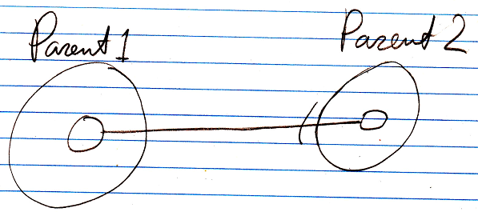

Instead of pointing to a →1 related item, you can just as well point to a →n related list item.

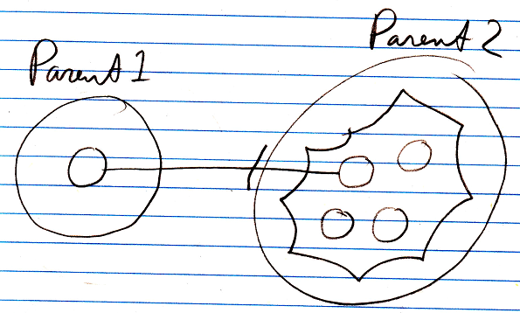

Pointing to another parent’s related item, means that the other parent has control over the eventual target pointed at. This is exactly what a pointer to pointer is applied for: giving another parent control over the eventual target pointed at.

When a related item points to a related item, that related item can again point to a related item, and so on.

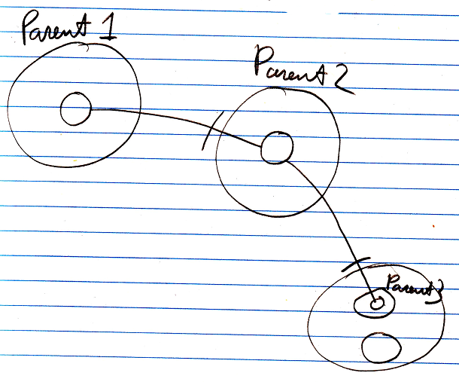

That’s how you create multiple pointer redirections.

So Parent 1 delegates its sub-object to Parent 2, granting Parent 2 control over the eventual target pointed at, which Parent 2 does, by deciding the eventual target is a related item inside Parent 3.
Parent 1 gives Parent 2 control the eventual target pointed at.

See also: System Objects, Pointer to Pointer

Author & Copyright: Jan-Joost van Zon Date: July 18, 2008 – July 18, 2008 Location: Oosterhout, The Netherlands Status: Finished

